**Decoding the Photosynthesis Code**

* **Respiration, Amax, Net**
  + Respiration: Estimate of max respiration
    - Min value in each data column
  + Net: Balance of max respiration and max carbon fixation
    - Max value in each column
  + Amax: Estimate of max carbon fixation
    - Net – Respiration
* **Saturating Light Intensity** 
  + The point at which highest carbon fixation is reached
    - Row number for max value of each column pulled out and row number matched to corresponding light intensity
    - If 2000 is max, then saturation was never reached
* **Quantum Yield**
  + The initial slope of the curve, representative of ratio of photons emitted : photons absorbed by the system
  + Between the first 4 points a straight line was not always created:

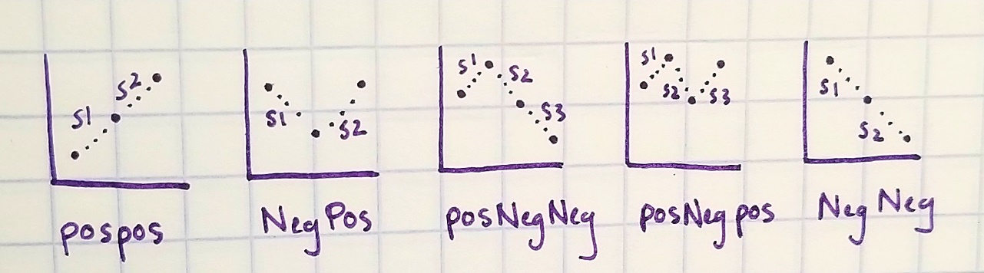

**Image 1.** Relationship between first 4 points of curve.

* + PosPos: Positive slope between points 1 & 2 and 2 & 3
    - Slope = mean of slope between points 1 & 2 and 1 & 3
  + NegPos: Negative slope between points 1 & 2, Positive between 2 & 3
    - Slope = slope 2
  + PosNegNeg: Positive slope between points 1 & 2, Negative between 2 & 3 and 3 & 4
    - Slope not calculated due to dip
  + PosNegPos: Positive slope between points 1 & 2, Negative between 2 & 3, Positive between 3 & 4
    - Slope = slope 3
  + NegNeg: Negative slope between point 1 & 2 and 2 & 3
    - Slope not calculated due to dip
* **Curve Shape**
  + Eight potential shapes
    - DownDown: PAR0 IS HIGHEST MARK: DOWN LIKE A LINE, DROP LIKE CLIFF AND DOWN
      * Exclude from data set
    - DownDownUp: PAR0 IS HIGHEST MARK: DROPS DOWN AND SCOOPS UP BUT NOT ABOVE PAR0
    - Scoop: LIKE A CHECK MARK WITH 2000 OVER PAR0
    - Normal: PLATEAUS LIKE A TABLE AFTER ~500, PARAMETERS WITHIN 15% OF PAR500
    - UpDown: CURVES UP THEN DIVES DOWN PRESUMABLY DUE TO PHOTODAMAGE
    - TipDown: CURVES UP AND DOESNT COME DOWN UNTIL LAST 2, 3, 4 POINT
    - UpUpUp: TIPS UP WITHOUT COMING DOWN
    - UpDownUp: SHAPED LIKE AN 'N'

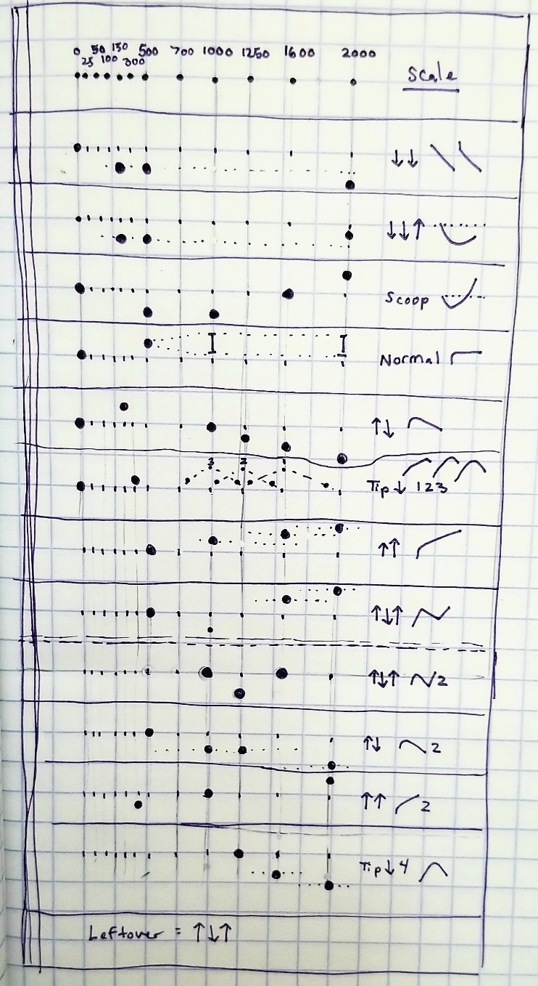

**Image 2.** Parameters in sequential order of sorting, last 5 categories are for clean up.